Trick Box is a personal development programme which has been developed by experts to support children’s emotional wellbeing, both in school and beyond. It is designed as parent/school/child tool to help children develop positive life habits and self-help strategies.
It consists of 24 simple tricks which children are introduced to through their time at St Peter’s. Each trick is developed further as they move up through school.
The first six tricks are introduced in YR and developed further as they move up through the school. Each year three new tricks are introduced.
Do ask your child about the tricks and how they use them in school. You will find ways that the tricks help in home situations. Also ask your child’s teacher for more information.
It is useful to have a box of cards at home to share – these are available at the office for £5.

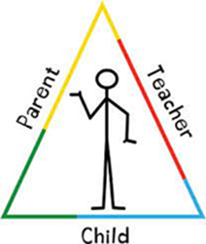

Autumn 1:  Mirror Mirror | Autumn 2:  Stand Tall | Spring 1:  Breathing Colour | Spring 2:  Floating Cloud | Summer 1:  Win Win | Summer 2:  Free Flow
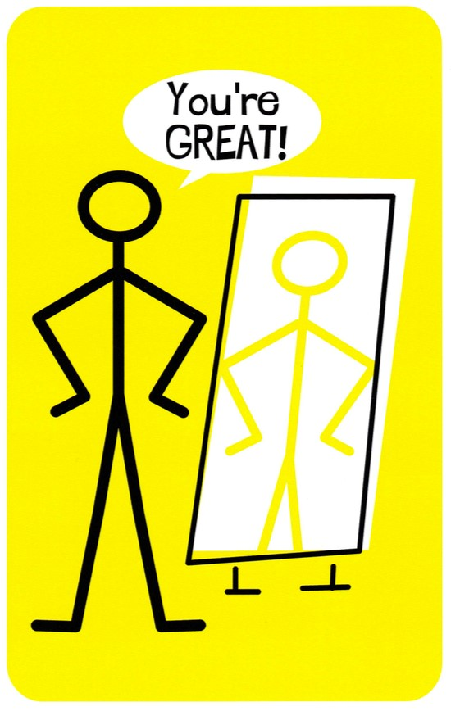 | 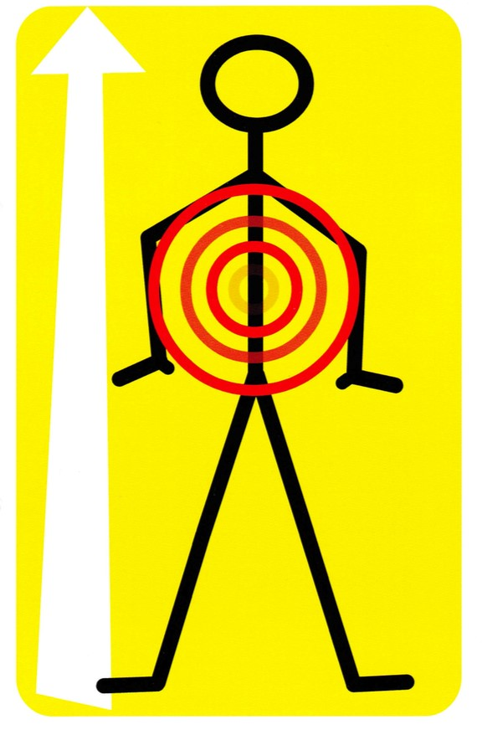 | 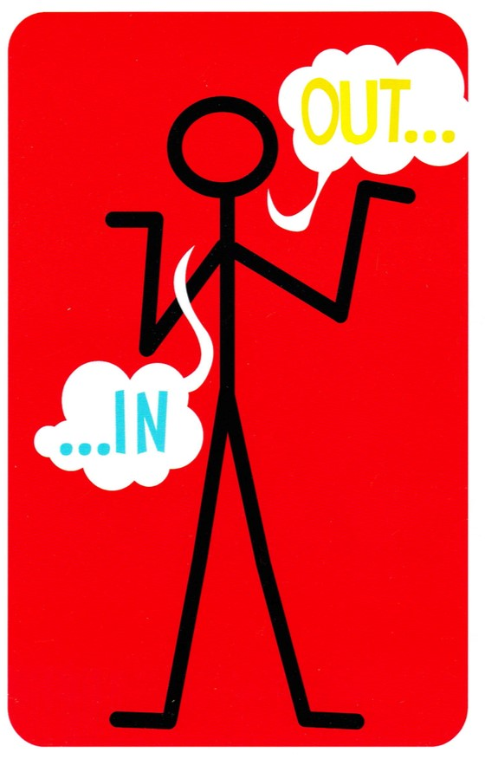 | 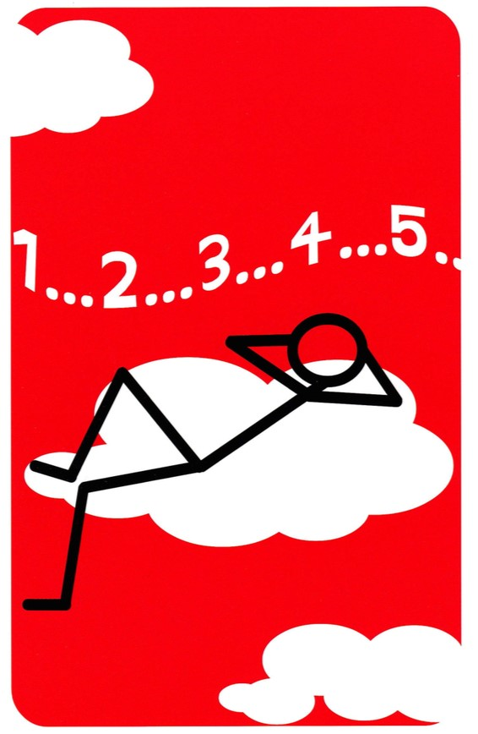 | 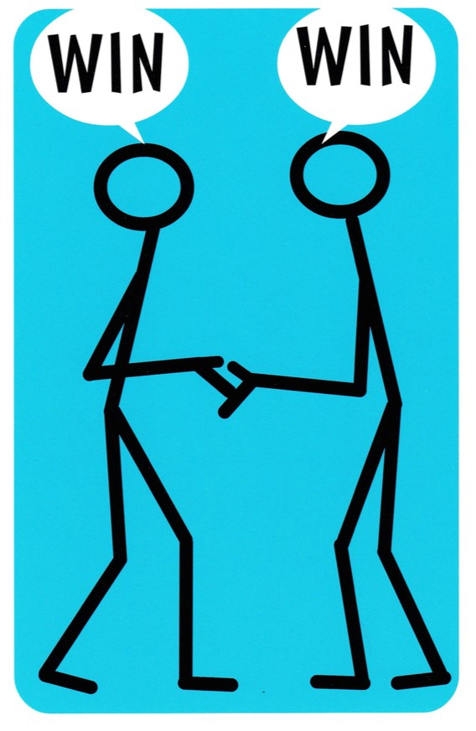 | 

