Take part in St Peter’s Wildlife Video!
Have you seen some beautiful nature while out on your daily exercise?
What can you see in your garden or from your window?
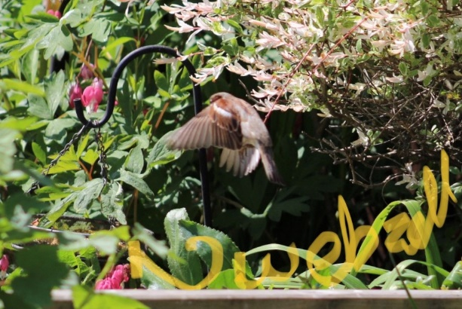
Look at this amazing picture that Mrs Webzell took in her garden:

Your challenge this week (should you wish to accept it) is to take a photo of some beautiful wildlife and send it to Mrs Webzell on:
forest@stpeters-farnham.surrey.sch.uk

Ideas are: bees, birds, butterflies, caterpillars, ladybirds, flowers, trees, plants, growing vegetables. These are just ideas – you get creative.

Three rules:
- No pets
- No people
- One photo per household

Closing date is Monday 18th May and Mrs Webzell and her team will turn the pictures into a video to share with everyone.

