Capacity and Volume Learning Year 1 based on Maths White Rose

Activity 1 – Introduce capacity and volume
If you can, you might first like to watch the clip for Week 1 Lesson 4 on https://whiterosemaths.com/homelearning/year-1/ Please don’t worry if you can’t do this .
- Find a range of different containers in your home. Eg a mug, glass, cup, jug, beaker, bucket, bottle, mixing bowl, dish , jam jar
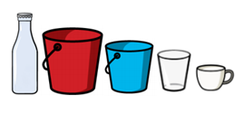
- Are they empty or full? What does empty mean? (It has nothing in it.) What does full mean? ( There is no more room for any more in it.) Find a full bottle – It might be a drink or even tomato ketchup!
- Take a glass tumbler or any cup and put some water in it. Can you make it - half full, almost full, half empty, almost empty, full ?
- Take another identical glass tumbler or cup and put different amounts of water in each. Which has the most water in it? Which has the least?
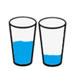
Maybe you could get two more identically sized tumblers or cups and leave one empty and put a different amount of water in the other ones. Can you put your cups in order from the least water to the most water.
 Are these in order?

- Would you prefer a half full glass of your favourite drink or an almost full glass? Why?
- Which is more – half full or half empty? Can you explain why?

Activity 2 Measure capacity and volume
If you can, you might first like to watch the clip for Week 1 Lesson 5 on https://whiterosemaths.com/homelearning/year-1/ Please don’t worry if you can’t do this .

- Find three different sized containers in your home. Eg an egg cup, a mug, and a large bowl
- Which container has the greatest capacity? Capacity is how much a container will hold, in other words how much, for example, juice or water it will hold.
- How many egg cups of water are needed to fill the mug?
- How many mugs of water will fill the large bowl?
Can you work out how many egg cups will fill the large bowl?
Hint: Remember you know how many egg cups will fill the mug.
- Can you work out how many mugs will fill two large bowls?
- What about three large bowls or four large bowls? Is there a pattern?
- Can you work out this problem?
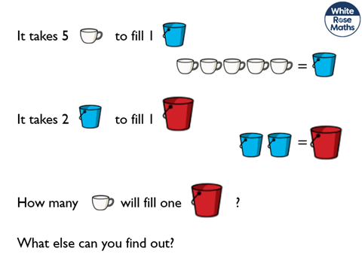

Activity 3 – Compare capacity
If you can, you might first like to watch the clip for Week 2 Lesson 1 on https://whiterosemaths.com/homelearning/year-1/ Please don’t worry if you can’t do this .
- Choose three containers each with a different capacity.
Which container do you think has the greatest capacity so it holds the most?
Which container has the smallest capacity so it holds the least?
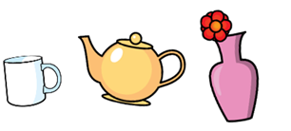
- Can you order the containers starting with the one that has the smallest capacity and ending with the one with the greatest capacity?
- Now order them from the greatest to the smallest.
- How could you compare the actual capacity of your three containers?
Hint : Can you measure how many of your smallest container fills the other containers?
- Draw some pictures to record what you have found out.

Well done !

