News from St Peter’s School
The term started with some fantastic news for the school: we heard that St Peter’s has been shortlisted for the tes teaching awards in the international category. The tes awards are held every year and are open to state secondary and primary schools, independent schools and schools overseas. There are eight schools shortlisted in the international category and we are one of only two primaries. One school is based in Delhi! To have reached this stage is a fantastic achievement and is testimony to the staff’s hard work which gives pupils at St Peter’s such diverse and exciting learning opportunities. Our global learning is integrated into the curriculum and challenges pupils to understand their place in the world and to think about big issues such as justice and children’s rights. Much of this learning is tied in with gospel values.
Following on from this, there is a tea reception at the House of Commons for the International Leader and the winning schools will be announced on June 21st at a reception in London for representatives from all of the schools. You can imagine that we are very excited and proud of all of the staff and pupils. Linked to this is the news that Ofsted’s focus is going to come away from test results to look more closely at the wider curriculum that schools are offering. We feel that this is a real strength at St Peter’s and this was acknowledged in our recent Ofsted report. But it’s great that this seems to be the future of primary education.
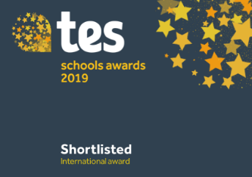
On the sports field we have just organised our second Farnham and District Schools Cross Country event. It takes place in Farnham Park on a Saturday morning and requires some staff to be on site from 7:15 am to set the course and marshal postings. It was an impressive turnout with almost 500 children from local schools participating. St Peter’s fielded 80 children with some fantastic results: Girls’ individual: 1st. Boys’ individual: 2nd. Girls’ team position 2nd and overall team position 3rd. There were 14 teams represented. Each week, staff are out at various sports events which are both competitive and inclusive. We were particularly proud of our Panathlon team of children who brought a 3rd placed trophy back from an event for children with additional needs held at Surrey Sports Park. This term’s focus is on athletics in preparation for the District Meet at Aldershot Stadium.
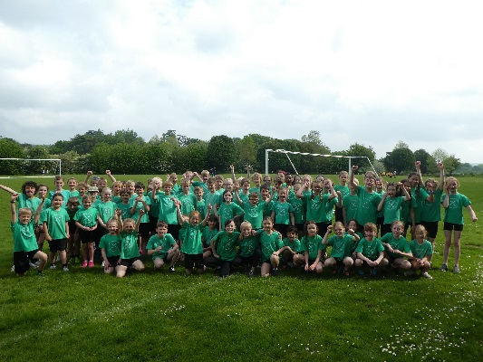
This term has been busy with a range of school trips to extend the curriculum: Y1 children visited Arundel Castle, Y4 experienced their first residential at PGL over in Churt, Y3 visited Wisley to support their Science topic and Y5 are exploring rivers over in Selborne. We are also taking a group of children to the Wintershall, Life of Christ drama.
We look forward to celebrating St Peter’s Day in church on June 28th.
For a running commentary on school life, do please follow our twitter feed: https://twitter.com/stpetersfarnham

